KELCO INDUSTRIES
KELCO 2D CUT
PROCESS FLOW DOCUMENT

Login to Role: Production Manager
Prerequisite for using Kelco 2D Cut (Item Setup)

Navigation: Lists -> Accounting -> Items.

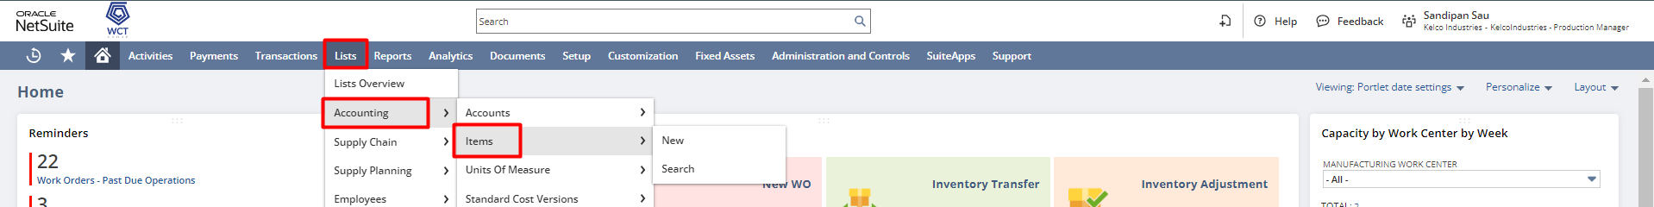

Edit the existing Item record.
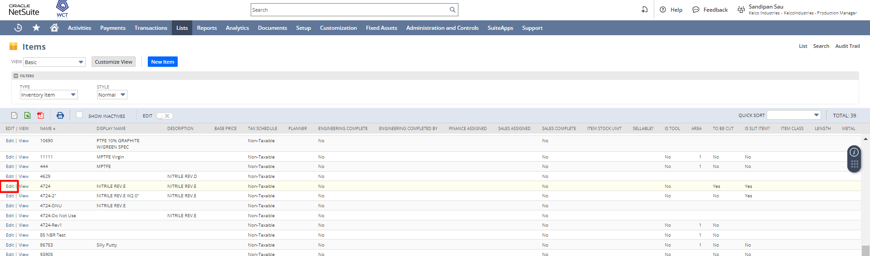
Check the To Be Cut checkbox and save the Item record.
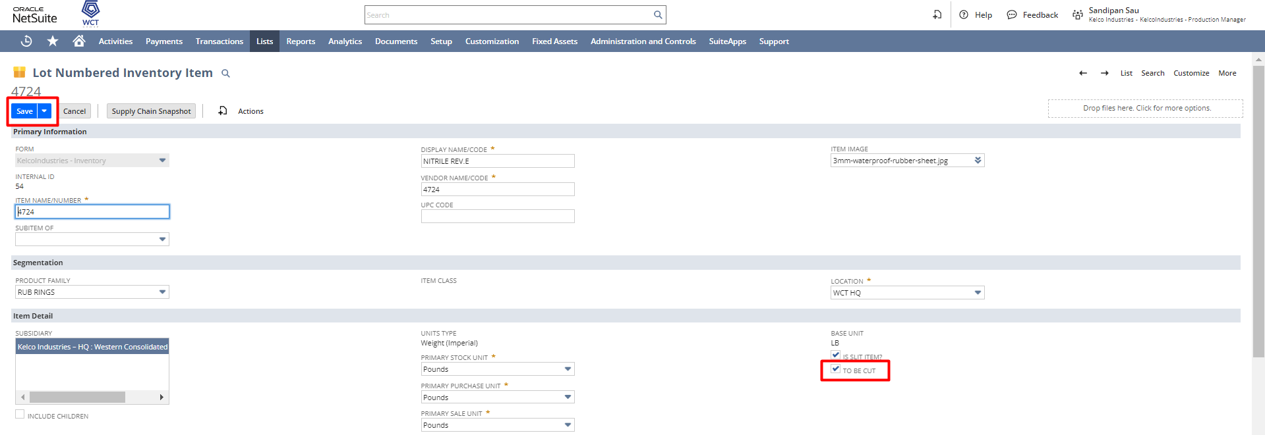

KELCO 2D Cut
To create a Kelco 2D Cut record the user needs to navigate Transactions-> Inventory-> Kelco 2D Cut-> New.
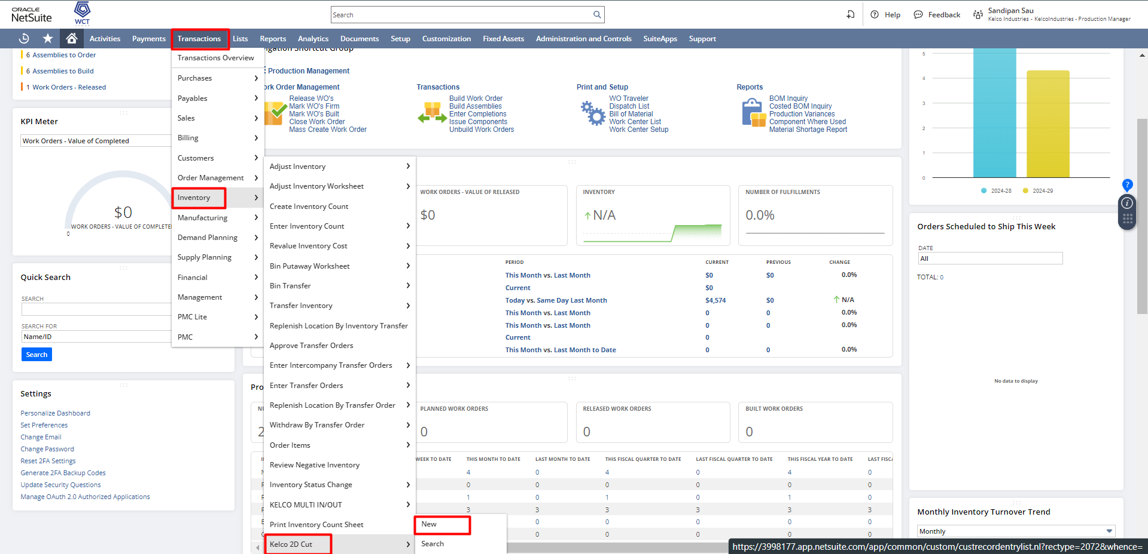

Enter the values of the fields like Raw Material (To Be Cut) which is the name of the item from which cutting will be done. Select the Location and the Lot Number and enter the Total Quantity that needs to be cut which includes the component quantity required for the work order. The Scrap Account field will have 5060 Scrap as the default account selected, and at the time of Inventory Adjustment, the account will reflect as the Adjustment Account.
Under the Work Order Details subtab, the user needs to select the Work Orders to which the cut item would be issued. Once the Work orders are selected it will auto-fetch the Work Order Quantity, but you have to enter the Quantity to Complete, and the Unit Cost.
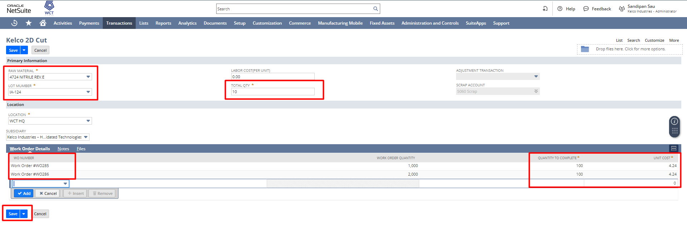
After entering all the details click on Save button.
After saving the Kelco 2D Cut, Work Order Issues will be created for those Work Order, and the system will generate an Inventory Adjustment for it.
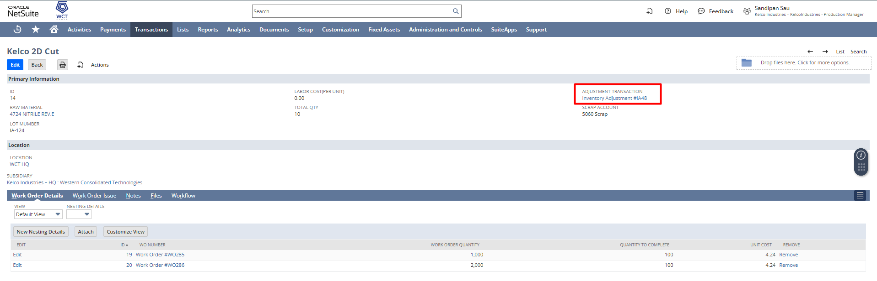
Work Order Issue
The user can access the created Work Order Issue record under the Work Order Issue subtab.

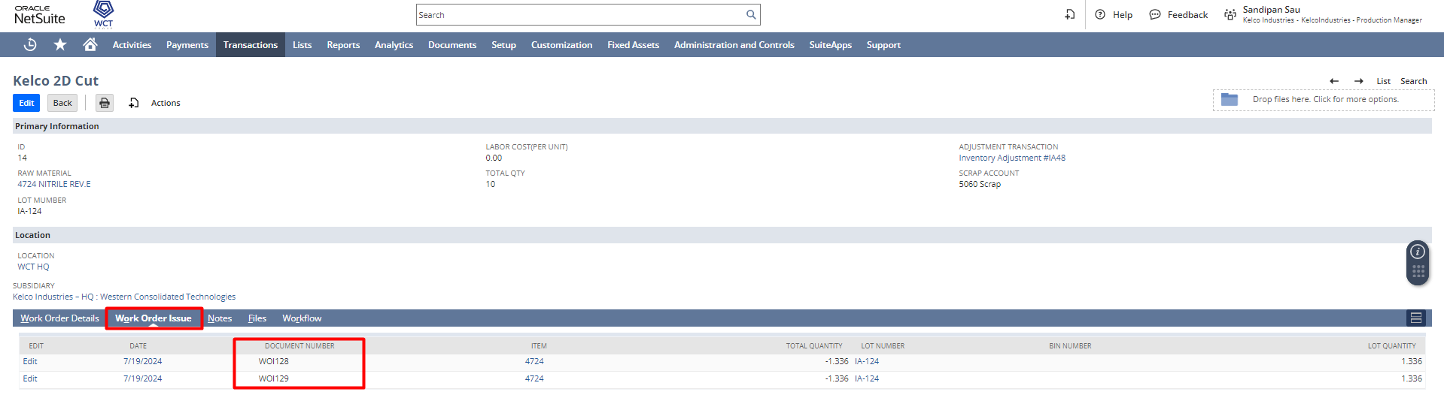

Inventory Adjustment
The user is required to access the Inventory Adjustment record using the Adjustment Transaction field found in the Kelco 2D Cut.
The Adjustment Account will be auto-fetched from the Scrap Account of Kelco 2D Cut and under the Adjustments subtab, the Quantities will be adjusted for the items.
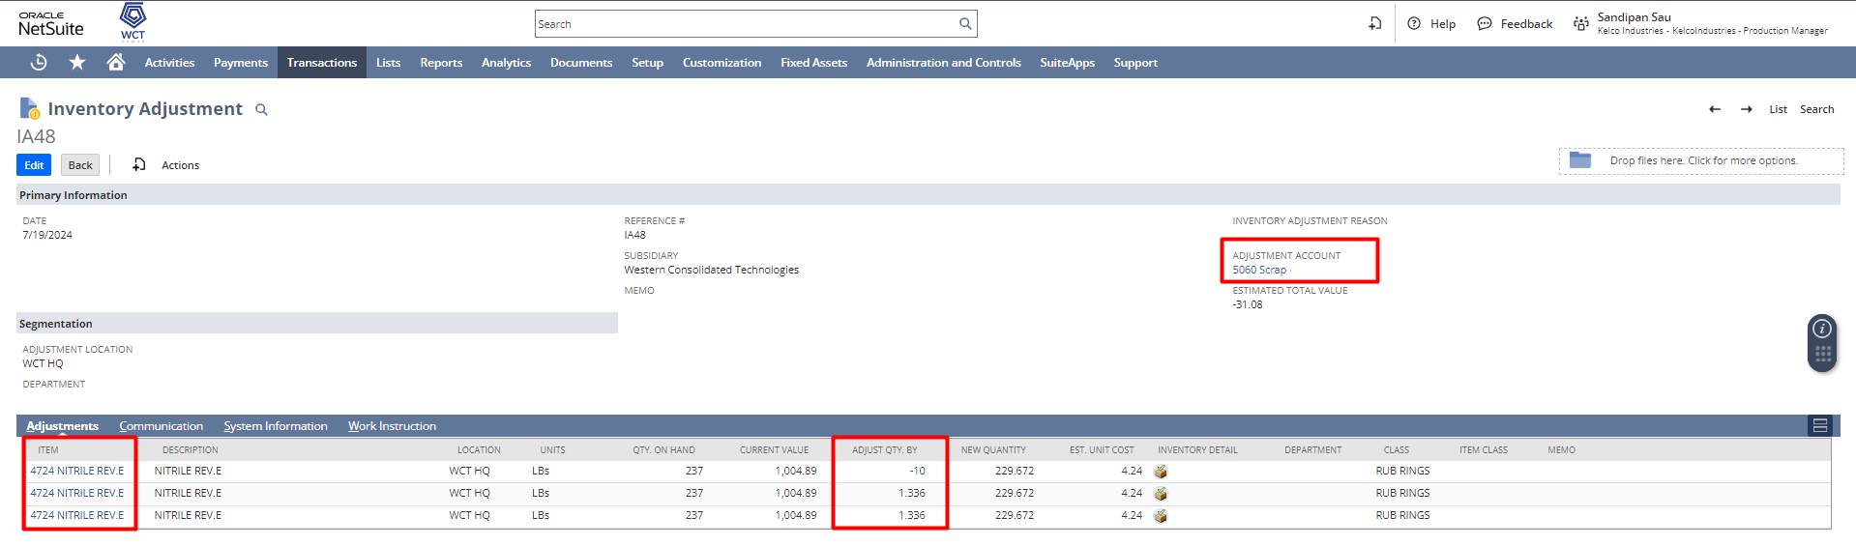
So for Adjust Qty By for the Input item will take what you entered in the Total Qty field in Kelco 2D Cut record, and for the Component Items what quantity you entered to issuing the material, based on that system will automatically calculate the quantity which needs to be issued and adjusting the same on the inventory adjustment.

Signature: ________________________________
Date: _____________________________________

Disclaimer:
Upon signing off on the process flow document, you are confirming that the process has been set up per the SOW within NetSuite per your business's needs. Any changes or modifications requested after sign-off will need to be a "change request" at an additional fee.

*** PLEASE ensure that you have logged into NetSuite and tested the process prior to signing off on the setup. Paapri requires sign-off on this document prior to moving forward with any additional design meetings.

